**Unit 5**

In VR, feedback refers to information relayed to the user about their actions and the state of the virtual environment, while constraints are limitations or restrictions within the VR system or environment. Effective feedback is crucial for immersion, learning, and performance in VR, while constraints can impact the realism and usability of the experience.

Feedback in VR:

* **Types of Feedback:**

VR utilizes various feedback mechanisms, including visual (e.g., actions being reflected in the virtual environment), auditory (e.g., sounds indicating actions), haptic (e.g., tactile feedback from virtual objects), and cognitive feedback (e.g., scores, progress bars).

* **Cognitive Feedback:**

This type of feedback helps users learn, understand, and improve their performance in VR through methods like scores, progress bars, and hints.

* **Haptic Feedback:**

Haptic feedback provides simulated tactile sensations, allowing users to feel virtual objects and interactions.

* **Multimodal Feedback:**

Combining multiple feedback mechanisms (e.g., visual, auditory, haptic) can enhance immersion and realism in VR.

Constraints in VR:

* **Materiality and Hardware:**

VR headsets and interfaces can be bulky and require cables, limiting freedom of movement and immersion.

* **Technical Limitations:**

Challenges exist in creating truly realistic haptic feedback, limited field of view, and technical difficulties in developing VR content.

* **Human Factors:**

Cybersickness (motion sickness experienced in VR) and user fatigue can be significant constraints.

* **Cost:**

VR equipment can be expensive, making it inaccessible for some users.

Temporal compliance in VR refers to ensuring that virtual environments accurately reflect the real-world temporal (time-related) aspects of a situation. This includes things like deadlines, time-sensitive actions, and the passage of time within the simulation. Solutions for temporal compliance in VR focus on creating believable and realistic time-based experiences, often using techniques like:

1. Realistic Time Passage:

* **Time-based progression:**

VR systems can simulate the passage of time within the virtual environment, allowing users to experience the effects of time-sensitive actions and deadlines. For example, a VR simulation of a stock market could accurately reflect the real-time fluctuations of prices based on simulated events.

* **Time dilation:**

Certain events or actions within the VR environment might be accelerated or slowed down to simulate different time scales, like a time-lapse of a construction project or a real-time emergency response.

2. Time-Sensitive Actions and Events:

* **Real-time interaction:**

VR simulations can allow users to interact with the virtual environment in real-time, responding to time-sensitive events and making decisions based on the current time and its impact on the simulation.

* **Time-dependent scenarios:**

VR simulations can be designed with specific time constraints or deadlines, forcing users to make timely decisions or face consequences, mirroring real-world scenarios.

3. User Feedback and Measurement:

* **Tracking performance:**

VR systems can track user performance based on their actions within the time-sensitive environment, providing feedback on their ability to manage time effectively.

* **Measuring compliance:**

VR can be used to assess a user's ability to follow time-related procedures or protocols in a safe and controlled environment, ensuring that they understand the time-sensitive aspects of the task.

4. Examples of Temporal Compliance in VR:

* **Safety training:**

VR simulations can incorporate time-sensitive scenarios like emergency evacuations, requiring users to make decisions and respond within a specific timeframe.

* **Medical training:**

VR simulations can be used to train medical professionals on time-critical procedures, such as surgery or emergency care, allowing them to practice under simulated pressure.

* **Productivity training:**

VR simulations can help employees learn to manage their time and prioritize tasks within a virtual office setting.

* **Pedestrian behavior studies:**

VR simulators can be used to study how time pressure affects pedestrian behavior in simulated traffic scenarios, which is difficult to study in real-world situations.

In VR, "spatial compliance" refers to the extent to which the virtual environment accurately and consistently reflects the user's physical movements and interactions in the real world. It's about how well the VR system tracks the user's location and actions, and how faithfully those actions are translated into the virtual space.

Elaboration:

* **Tracking and Mapping:**

Spatial compliance relies heavily on the VR system's ability to track the user's position and orientation in the real world and accurately map it to the virtual environment. This often involves using sensors, cameras, and other technologies to capture the user's movements and create a virtual representation of their physical space.

* **Interaction and Control:**

Spatial compliance also impacts how users interact with objects and the virtual environment. For example, if a VR system has poor spatial compliance, a user might feel that their virtual hands don't correspond to their physical hands when reaching for an object, making the experience feel unnatural and less immersive.

* **Immersive Experience:**

Accurate spatial compliance is crucial for creating an immersive and believable VR experience. If the virtual environment doesn't match the real world, it can disrupt the user's sense of presence and immersion, leading to disorientation or even motion sickness.

* **Applications:**

Spatial compliance is important in a wide range of VR applications, including:

* + **VR gaming:** Accurate spatial tracking is essential for games that involve movement, exploration, and interaction with the virtual world.
  + **VR training:** In VR training simulations, spatial compliance ensures that the virtual environment accurately reflects the real-world environment, making the training more realistic and effective.
  + **VR collaboration:** When multiple users are collaborating in a virtual environment, spatial compliance ensures that everyone's movements and interactions are synchronized and consistent.

**"Nuling compliance**" in VR refers to the property where when a user returns a device (like a haptic glove or VR controller) to its initial position or orientation, the corresponding virtual object or interaction also returns to its initial state. This ensures that the user's actions have a consistent and predictable outcome in the virtual environment.

In essence, it's the guarantee that the virtual world responds to the user's physical actions in a mirrored way, returning to a known state when the user's physical device is reset. This is a fundamental aspect of designing intuitive and usable 3D user interfaces.

For example, if a user is using a haptic glove to hold a virtual object, and they return the glove to its original position, the virtual object should also return to its original position in the VR environment. This "nulling compliance" makes the interaction feel natural and predictable, as if the user is interacting with a physical object in the real world.

In Virtual Reality (VR), "sensory dimensions compliance" refers to the extent to which a VR experience faithfully replicates and engages the human senses, ensuring a realistic and immersive feeling. This means accurately simulating visual, auditory, haptic, and potentially olfactory and gustatory experiences. Compliance also involves addressing potential issues like motion sickness or discomfort caused by poorly designed VR environments.

Here's a more detailed breakdown:

Key aspects of sensory dimensions compliance in VR:

* **Visual fidelity:**

Creating realistic visual environments with accurate colors, lighting, and textures is crucial.

* **Auditory realism:**

Soundscapes should accurately represent the virtual environment, including spatial audio and realistic sound effects.

* **Haptic feedback:**

Using haptic devices or incorporating haptic feedback into the VR experience allows users to "feel" virtual objects and interactions, enhancing immersion.

* **Other senses (Olfaction and Taste):**

While still in the early stages, research is exploring ways to incorporate smell and taste stimulation into VR experiences.

* **Motion sickness and discomfort:**

Ensuring that the VR experience is comfortable and avoids causing motion sickness is essential for a positive user experience.

* **Accessibility:**

Designing VR experiences that are accessible to a wide range of users, including those with disabilities, is also important.

Why is sensory dimensions compliance important in VR?

* **Enhanced immersion and engagement:**

A more realistic and immersive VR experience can significantly enhance user engagement and make the experience more enjoyable.

* **Improved learning and training:**

VR can be used for education and training by providing realistic simulations of real-world scenarios, and good sensory compliance is key to the effectiveness of these simulations.

* **Increased realism and accuracy:**

In fields like medical training, VR can be used to simulate surgical procedures or other medical processes, and good sensory compliance is crucial for the accuracy and effectiveness of these simulations.

* **Better consumer understanding:**

In consumer testing and product development, VR can be used to simulate consumer experiences in a virtual environment, and good sensory compliance can help to better understand consumer behavior and preferences.

Examples of sensory dimensions compliance in VR:

* **Virtual tours of historical sites:**

VR can recreate the sights, sounds, and even smells of historical locations, allowing users to experience history in a more immersive way.

* **Medical training simulations:**

VR can simulate the sights, sounds, and even the haptic feedback of surgical procedures, allowing medical students to train in a safe and controlled environment.

* **Product development and testing:**

VR can be used to simulate the experience of shopping for a product in a virtual store, allowing designers to test product placement and other aspects of the shopping experience.

In the context of constraint satisfaction, artificial constraints are limitations placed on a problem to simplify it or guide the search for solutions, while physically realistic constraints represent limitations based on real-world laws and behaviors. In Virtual Reality (VR), these constraints can be used to design interactive experiences that are both fun and safe.

**Artificial Constraints:**

* **Simplified Rules:**

Instead of trying to simulate every aspect of reality, artificial constraints might introduce simplified rules to make a problem more tractable. For example, in a game, you might use simplified physics or movement mechanics for the player's character.

* **Problem-Solving Techniques:**

These constraints can also guide the use of specific algorithms or strategies to solve a problem. For example, in Sudoku, constraints are used to define valid placements of numbers, and algorithms like backtracking or constraint propagation can be used to find solutions.

* **Abstraction:**

Artificial constraints often involve abstraction, where certain details are omitted or simplified to make the problem easier to handle. This is common in computer graphics and simulations where the environment may not perfectly represent the real world.

**Physically Realistic Constraints:**

* **Laws of Physics:**

These constraints are based on real-world physical principles, such as gravity, momentum, and collision detection. They aim to create a simulation that behaves in a way that aligns with the real world.

* **Material Properties:**

In VR, realistic constraints can also include material properties like density, stiffness, and friction. This allows objects in the virtual environment to interact with each other in a believable way.

* **User Safety:**

In VR, physical constraints are also crucial for user safety. For example, constraints can be used to prevent users from walking through walls or colliding with objects in the real world.

Examples in VR:

* **Redirected Walking (RDW):**

This technique uses artificial constraints to create the illusion of walking in a larger space while limiting the user's physical movement to a smaller area. This is important for safety and portability.

* **Constraint-Based Animation:**

Physically realistic constraints are used in computer graphics and animation to create believable movement and interactions. For example, constraints can be used to model the flexible movement of cloth or the joints of a human body.

* **Collision Detection:**

In VR, collision detection is a crucial physical constraint that prevents users from walking through objects or colliding with real-world obstacles.

* **Haptic Feedback:**

Haptic feedback provides users with a sense of touch and resistance, which can be used to make interactions in VR feel more realistic. This can be achieved through artificial constraints, such as simulating the feeling of pressing a button or holding an object.

Human Factors for Developing VR Applications

Developing successful VR applications requires careful consideration of human factors to ensure a positive user experience and minimize potential issues like cybersickness or fatigue. Key areas include ergonomics, cognitive ergonomics, and the interplay between the virtual and physical environments.

1. Ergonomics and Physical Comfort:

* **Headset Comfort:**

VR headsets need to be comfortable, light, and fit well to avoid physical strain.

* **Repetitive Strain Injuries (RSIs):**

VR experiences can lead to RSIs, so designing for natural movements and minimizing repetitive actions is crucial.

* **Hygiene and Safety:**

Address hygiene concerns, particularly in shared VR environments, and ensure safety protocols for potential injuries.

2. Cognitive Ergonomics:

* **Immersion and Suspension of Disbelief:**

Create immersive environments that encourage users to suspend their disbelief and fully engage in the virtual world.

* **User Interface (UI) and User Experience (UX):**

Design intuitive interfaces that are easy to use and navigate, minimizing frustration and cognitive burden.

* **Cognitive Abilities:**

Consider how VR experiences might affect users' cognitive abilities, such as spatial reasoning and memory, and design accordingly.

3. Sensory Integration and Virtual Environment:

* **Visual and Vestibular Mismatch:**

Ensure consistent sensory cues to prevent motion sickness (cybersickness) caused by conflicting visual and vestibular signals.

* **Display Quality:**

High-quality displays with good resolution and frame rates are crucial for a smooth and immersive experience.

* **Field of View (FOV):**

Maximize the FOV to provide a more realistic sense of presence.

* **Depth Perception:**

Design virtual environments with accurate depth perception cues to enhance immersion and prevent disorientation.

* **Sound and Haptic Feedback:**

Integrate sound and haptic feedback to enhance the realism and engagement of VR experiences.

4. Human-Computer Interaction:

* **Intuitive Interactions:**

Design interfaces that are easy to learn and use, allowing users to interact with the virtual environment naturally.

* **Input Methods:**

Consider various input methods, such as hand controllers, voice recognition, and natural language processing, to cater to different user preferences.

* **Feedback Mechanisms:**

Provide clear and timely feedback to users on their actions and the state of the virtual environment.

**What is AR/VR testing?**

AR/VR testing is the process of evaluating AR/VR applications to make sure they deliver full-stack functionality, compatibility, reliability, usability, security, maintainability and performance. Given the immersive nature of AR/VR experiences, testing these applications involves unique challenges and methodologies compared to traditional software testing. The user might experience headaches, motion sickness, seizures, eye strain, and other symptoms. These make it necessary to conduct such AR/VR tests.

**Challenges in AR/VR Testing**

Here are the main Challenges in AR/VR Testing are follows:

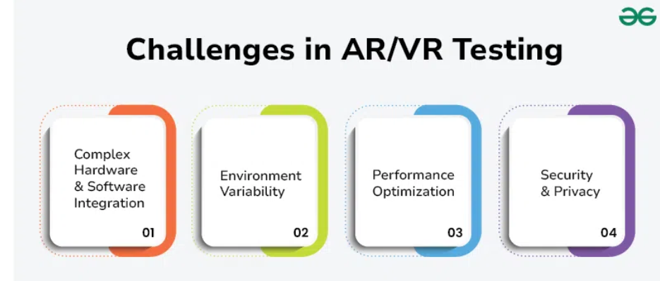

### ****1. Complex Hardware and Software Integration****

Testing AR/VR apps involves the use of such devices as VR headsets, motion sensors and AR glasses. Each of these devices has its own specifications, capabilities and limitations. In this case, it requires testing for hardware compatibility across all platforms.

### ****2. Environment Variability****

Real-world AR applications have to run on all sorts of real-world environments that can differ significantly in terms of lighting, textures, and physical spaces. These features of the environment play a role in object recognition and tracking.

### 3. Performance Optimization

Resource-hungry AR/VR apps typically require high-end graphics and real-time processing for seamless user experience. However, ensuring that the app runs on all supported devices without sacrificing quality is not an easy task.

### 4. Security and Privacy

Virtual reality and augmented reality apps often gather and handle important user data, like biometric info and real-world scans. It's crucial to keep this data safe and private, so thorough testing is needed to find and fix any possible weaknesses.

## Test Strategy AR/VR Applications

### Step 1 : Understand the Requirements

Collecting necessary data required helps us understand the functionality of the application. The goal and purpose behind the application are explored and then it would be converted into a storyboard to help the engineers understand all potential scenarios for user engagement. This phase helps to understand various goals of the application.

### Step 2 : Test Initialization

With a strong test suite consisting of right set of test cases, we can begin our testing phase. It mainly includes identifying the right set of devices and other products which would support the process should be included in the test plan. Understand the test environment and figure out how to set up and run the tests.

### Step 3 : Scope of Testing

Here we track the object in real-time and check whether the 2D/3D objects are registered by the application, thus coming under our testing scope. With multiple inputs check the performance of the application and note down the test data. Check if the AR/VR model redirects to any specific data. Also, we check the application’s [GUI](https://www.geeksforgeeks.org/what-is-graphical-user-interface/) to understand and solve any errors within the product. With all this referred and documented we would have a clear picture of the scope and expectations.

### Step 4 : Decide the Kind of Testing to be Performed

When testing AR/VR applications we have to include multiple types of testing for better analysis. Tests include functional test, usability test, immersive test, hardware test, configuration test, security test and many more. We have to tailor our tests based on the project requirement and check whether the application follows all the regulations and standards set by the industry.

### Step 5 : Work collaboratively with Developers

As engineers part of the team, we would have the great opportunity to collaborate with the developers who use cutting-edge technologies. It can enable us to learn new technologies and skills for the project. We can align ourselves with the developers to understand the new technology and work partially to make the application better.

## Types of Testing in AR/VR Testing

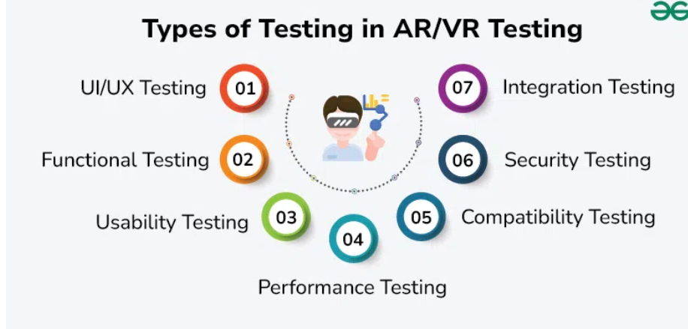Types of Testing in AR-VR Testing

### 1. UI/UX Testing

* The advantages of UI/UX testing in AR/VR focus on the effective realization of interfaces and user-friendliness by checking gesture controls or readability and spatial experience.
* It aims at user interaction, satisfaction, and ease of use; it resolves such issues such as device heterogeneity and delay.

### 2. Functional Testing

* [Functionality tests](https://www.geeksforgeeks.org/software-testing-functional-testing/) refer to the assessment of the application's performance in the AR/VR space.
* Such tests aim to confirm that virtual objects operate correctly and that interaction through gesture and voice is properly detected as alternate ways to interact with the system.

### 3. ****Usability Testing****

* Evaluates the user experience within the AR/VR environment.
* Assesses ease of use, user interface design, and the intuitiveness of interactions.
* Collects user feedback to identify pain points and areas for improvement.

### 4. ****Performance Testing****

* Measures the responsiveness and stability of the application under different conditions.
* Tests for frame rates, latency, and loading times to ensure a smooth user experience.
* Identifies performance bottlenecks and optimizes resource usage.

### 5. Compatibility Testing

* [Compatibility Testing](https://www.geeksforgeeks.org/compatibility-testing-in-software-engineering/) for fit makes sure the AR/VR app works well on many tools, setups, and tech types.
* This means trying it out on various AR/VR gears, phones, and operating systems (iOS, Android, Windows, macOS).
* Each gadget might have special stuff like different cam levels for AR or changes in how VR helmets sense motion.
* It also looks at how well it works with extra items like game pads, motion catchers, and extra cams, making sure it all works well together.

### 6. Security Testing

* [Security Testing](https://www.geeksforgeeks.org/security-testing/) will checking the security of AR/VR apps is very important to keep user data safe.
* This includes finding weak points and making sure the app follows rules about protecting data, like the [GDPR](https://www.geeksforgeeks.org/general-data-protection-regulation-gdpr-considerations/) and CCPA.
* Security tests look at things like how data is sent, how information is coded, making sure users are who they say, and who can get into the app.

## AR/VR Use Case

### Example: Osso VR

### Description

Osso VR is designed to let doctors practice surgeries in a virtual environment. It is almost real and assists the doctors to cumulatively perform various surgeries. Virtual has real like models of the body and it also provides feedback to the doctors immediately. This assists them to gain better practices in surgeries by developing their skills as well as enhancing the essence of surgery.

### Benefits

* **Risk Free Practice**: They avoid exposing patients to and risk their lives while surgeons can practice on them intricate operations.
* **Cost Effective**: Saves on unnecessary and other expensive training materials which are vital in training the cadets.
* **Skill Assessment:** Evaluation enables the trainers to show the trainees how efficient they are and the areas that they need to work on.